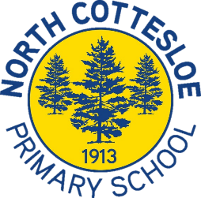
North Cottesloe Music
Performance Information

Event | Year 6 Graduation 2023
Performers | VOCAL ENSEMBLE (Year 5 and 6 only)  CONCERT BAND
Staff | Mrs Jennifer Fine
Repertoire | As discussed with conductor during rehearsals.
Venue | North Cottesloe Primary School.  Under cover area.
Date | Tuesday 12 December
Times | Arrive at 4.30 pm in the Music room for a sound check and warm-up.  The ceremony starts at 5 pm and concludes at 6.30 pm.  Year 5 students may leave once they have performed in the first section of the ceremony.
Rehearsals | Will be held during our usual morning rehearsal times for Vocal Ensemble and Concert Band.
Attendance | Compulsory for all students in Concert Band and Vocal Ensemble (Year 5 and 6 only). All families of student musicians are warmly invited to attend the Year 6 Graduation Night performance.
Travel | School based performance.
Uniform | Year 5 students wear full concert uniform including black music shirt, black pants, black socks and shoes. Long hair must be tied back off shoulders.  Year 6 students wear their graduation uniform of white shirt and blue shorts/skirt.
Questions | If you have any questions please contact Mrs Fine: Jennifer.Fine@education.wa.edu.au

